关于《义乌（苏溪）国际枢纽港规划与重点地段城市设计国际方案征集公告》有关内容修订的公告

由义乌自由贸易发展区管理委员会、义乌市自然资源和规划局联合主办的《义乌（苏溪）国际枢纽港规划与重点地段城市设计》国际方案征集活动，于2024年3月18日发布正式公告。现对征集公告进行修订如下：

原文：
- 征集范围
- Scope of Work
本次方案征集范围包括2个层次，分别为规划研究范围、重点地段城市设计范围。（详见附图）
The scope of this proposal solicitation encompasses two spatial level: the planning research scope and the urban design scope in key areas. (Refer to the attached diagram for details)
（1）规划研究范围：面积约31.6平方公里，主要目标是衔接国土空间总体规划，明确国际枢纽港核心功能和规模，完善陆港集疏运交通体系，优化总体布局。
Planning research scope: Approximately 31.6 square kilometers in area, the main objective is to align with the comprehensive territorial spatial planning, define the core functions and scale of the international hub port, improve the land-port integrated transportation system, and optimize the overall spatial distribution.
（2）重点地段城市设计范围：在划定的设计范围内选择约3—4平方公里进行重点城市设计。主要目标是进一步完善布局、功能、强度、形态等，系统塑造枢纽港特色景观风貌，提出各类公共空间和地块系统的建设管控和引导要求。
Key area urban design scope: Within the delineated design area, approximately 3-4 square kilometers will be selected for focused urban design. The main objective is to further refine the layout, functions, intensity, and forms, while systematically shaping the distinctive landscape and aesthetic characters of the hub port. Moreover, it involves proposing construction, control, and guidance requirements for various types of public spaces and land parcels.
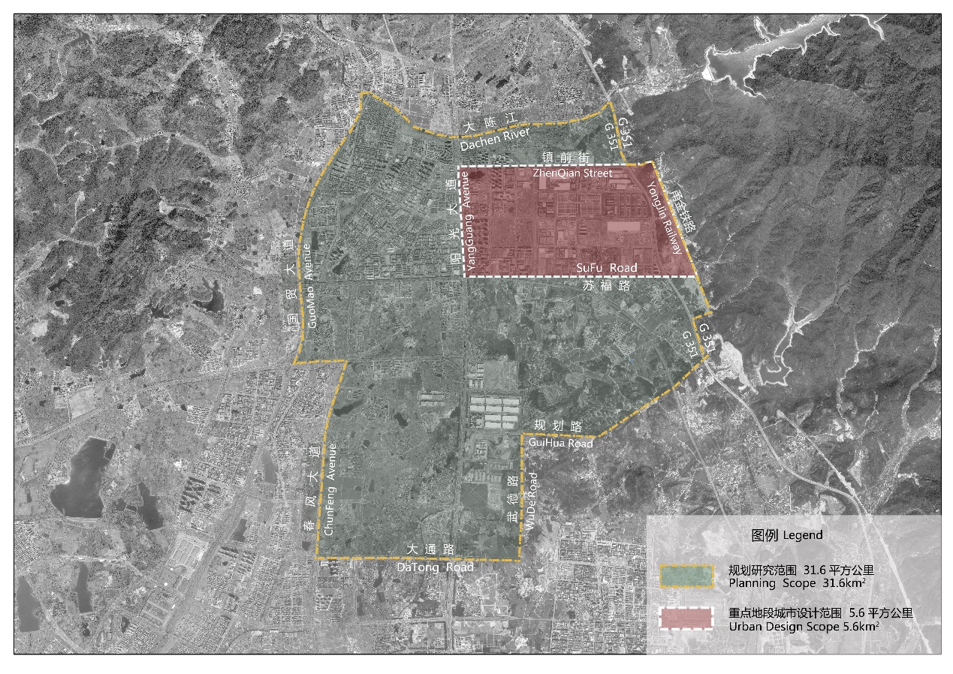
方案征集范围
Scopes of the Proposal Solicitation

修改为：.
- 征集范围
- Scope of Work
本次方案征集范围包括2个层次，分别为规划研究范围、重点地段城市设计范围。（详见附图）
The scope of this proposal solicitation encompasses two spatial level: the planning research scope and the urban design scope in key areas. (Refer to the attached diagram for details)
（1）规划研究范围：面积约34.5平方公里，主要目标是衔接国土空间总体规划，明确国际枢纽港核心功能和规模，完善陆港集疏运交通体系，优化总体布局。
Planning research scope: Approximately 34.5 square kilometers in area, the main objective is to align with the comprehensive territorial spatial planning, define the core functions and scale of the international hub port, improve the land-port integrated transportation system, and optimize the overall spatial distribution.
（2）重点地段城市设计范围：在划定的设计范围内选择约3—4平方公里进行重点城市设计。主要目标是进一步完善布局、功能、强度、形态等，系统塑造枢纽港特色景观风貌，提出各类公共空间和地块系统的建设管控和引导要求。
Key area urban design scope: Within the delineated design area, approximately 3-4 square kilometers will be selected for focused urban design. The main objective is to further refine the layout, functions, intensity, and forms, while systematically shaping the distinctive landscape and aesthetic characters of the hub port. Moreover, it involves proposing construction, control, and guidance requirements for various types of public spaces and land parcels.
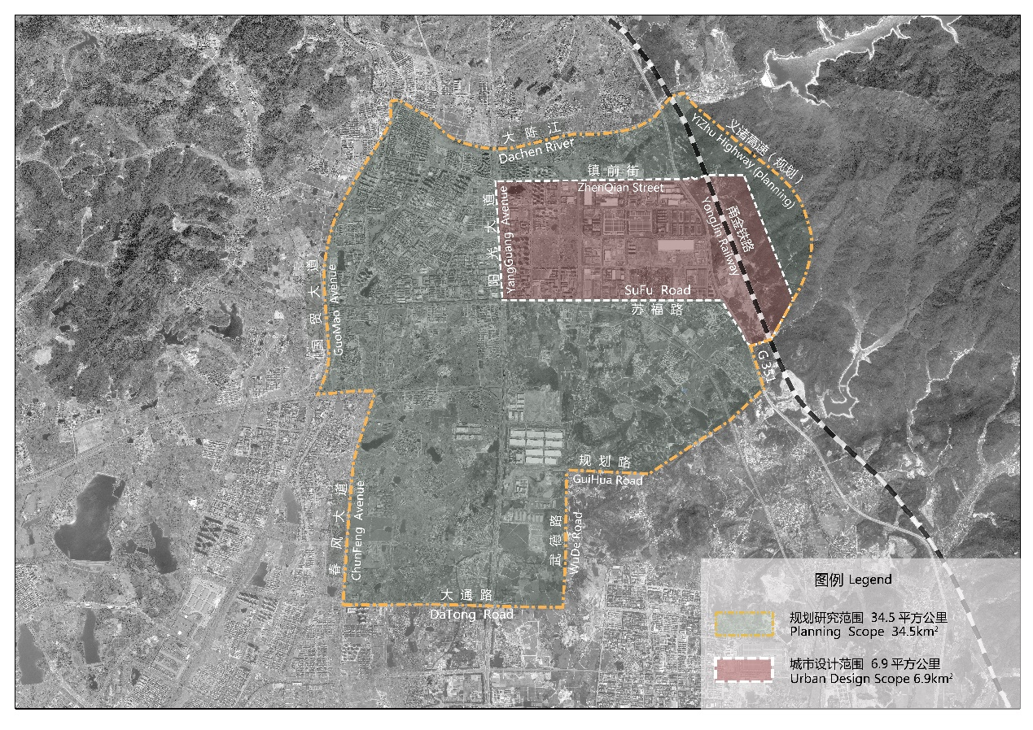
方案征集范围
Scopes of the Proposal Solicitation

特此说明。

2024年3月28日
义乌自由贸易发展区管理委员会
义乌市自然资源和规划局

