《苏州科技城核心区TOD综合开发城市设计》
国际方案征集公告
Announcement on International Solicitation for
Urban Design of the Core Area Integrated TOD of Suzhou Science and Technology Town
附图
Figure

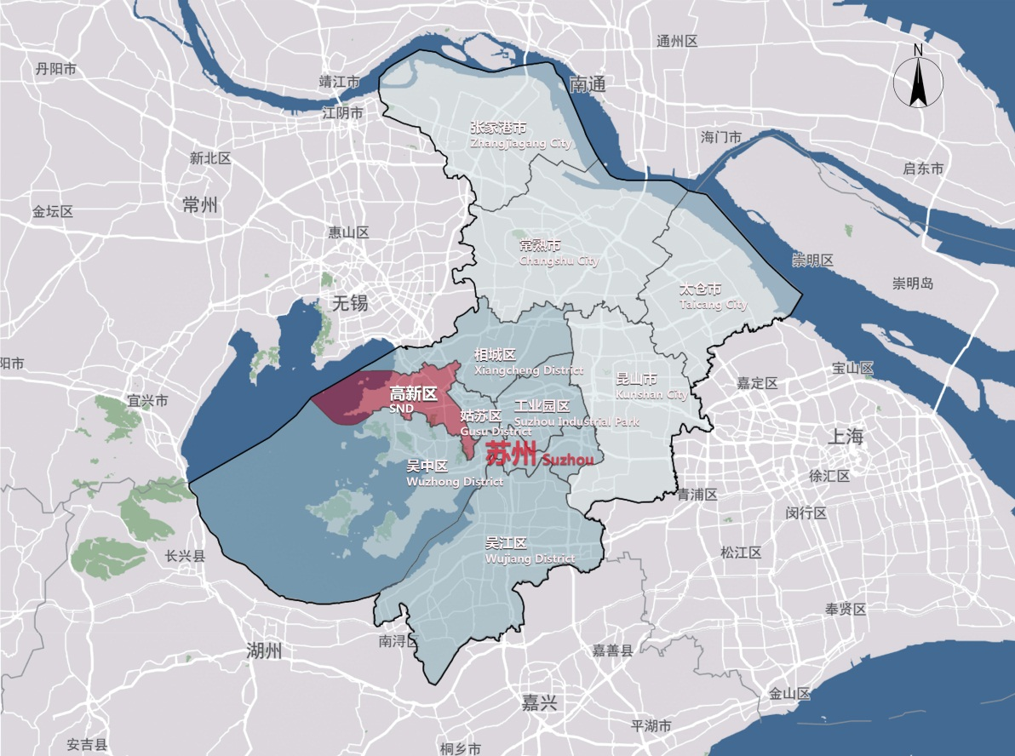
图1 高新区区位示意图
Figure 1. Location of SND

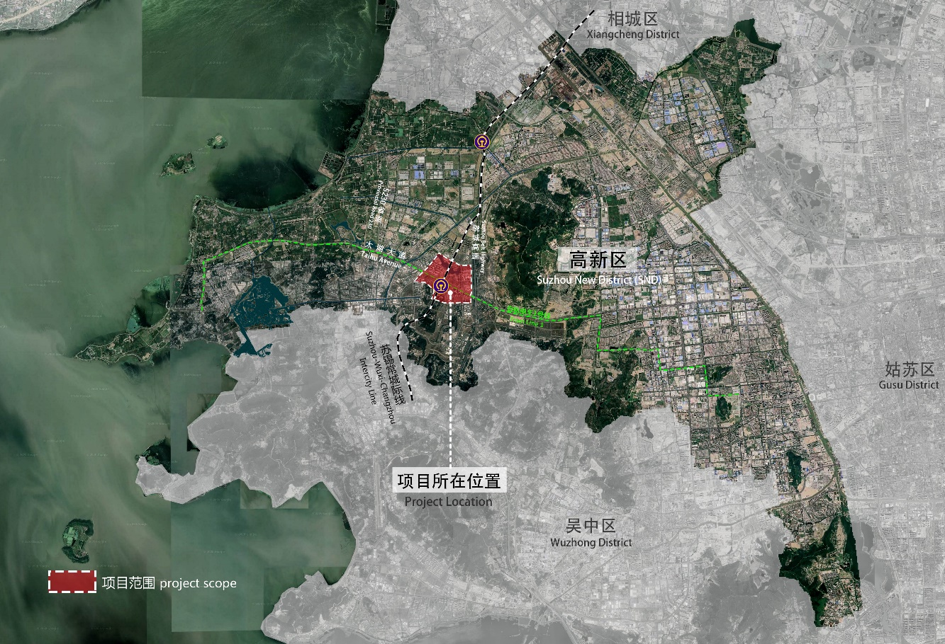
图2 项目区位示意图
Figure 2. Location of the project
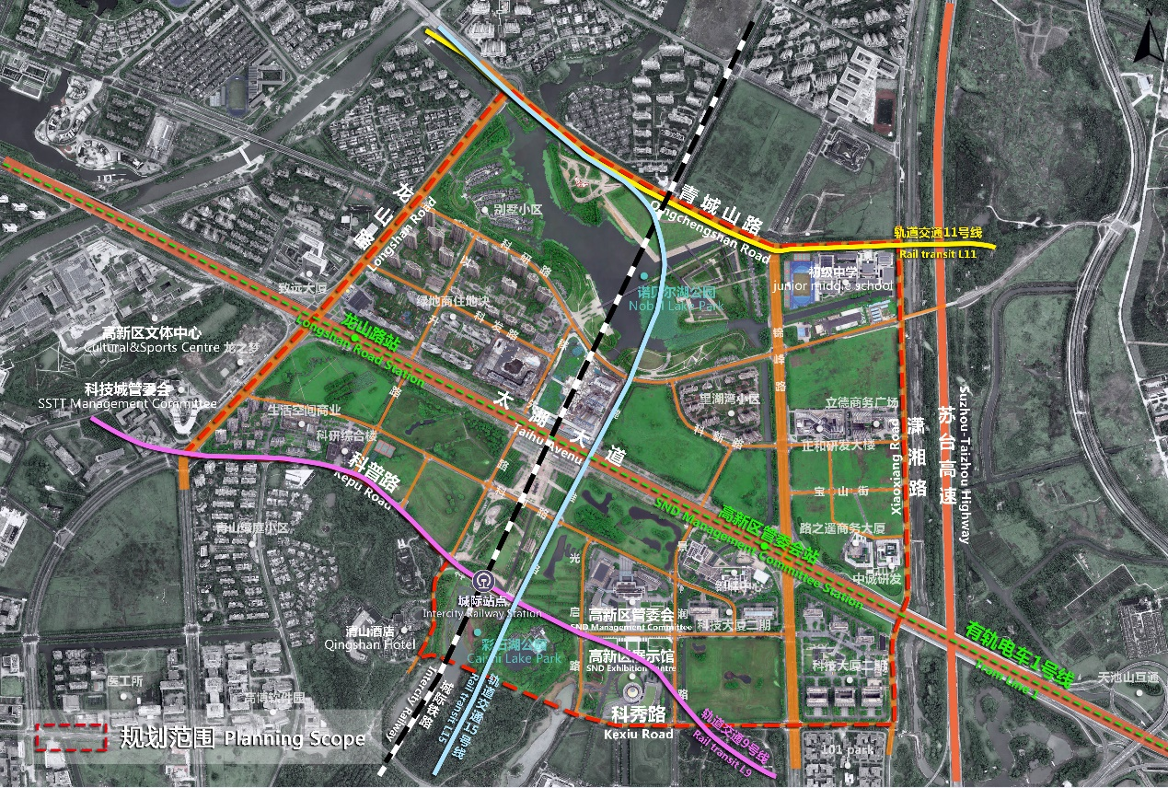
图3 设计范围示意图
Figure 3. Diagram of the design scope

