沈阳王家湾滨水地区城市设计
国际方案咨询公告
Announcement on International Solicitation for Urban Design of Shenyang Wangjiawan Waterfront Area
附图
Figure

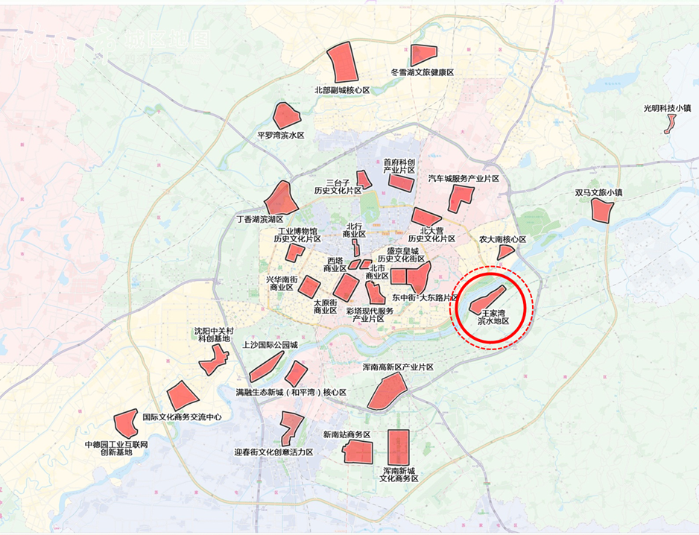

图1 王家湾滨水区区位示意图
Location map of Wangjiawan waterfront area
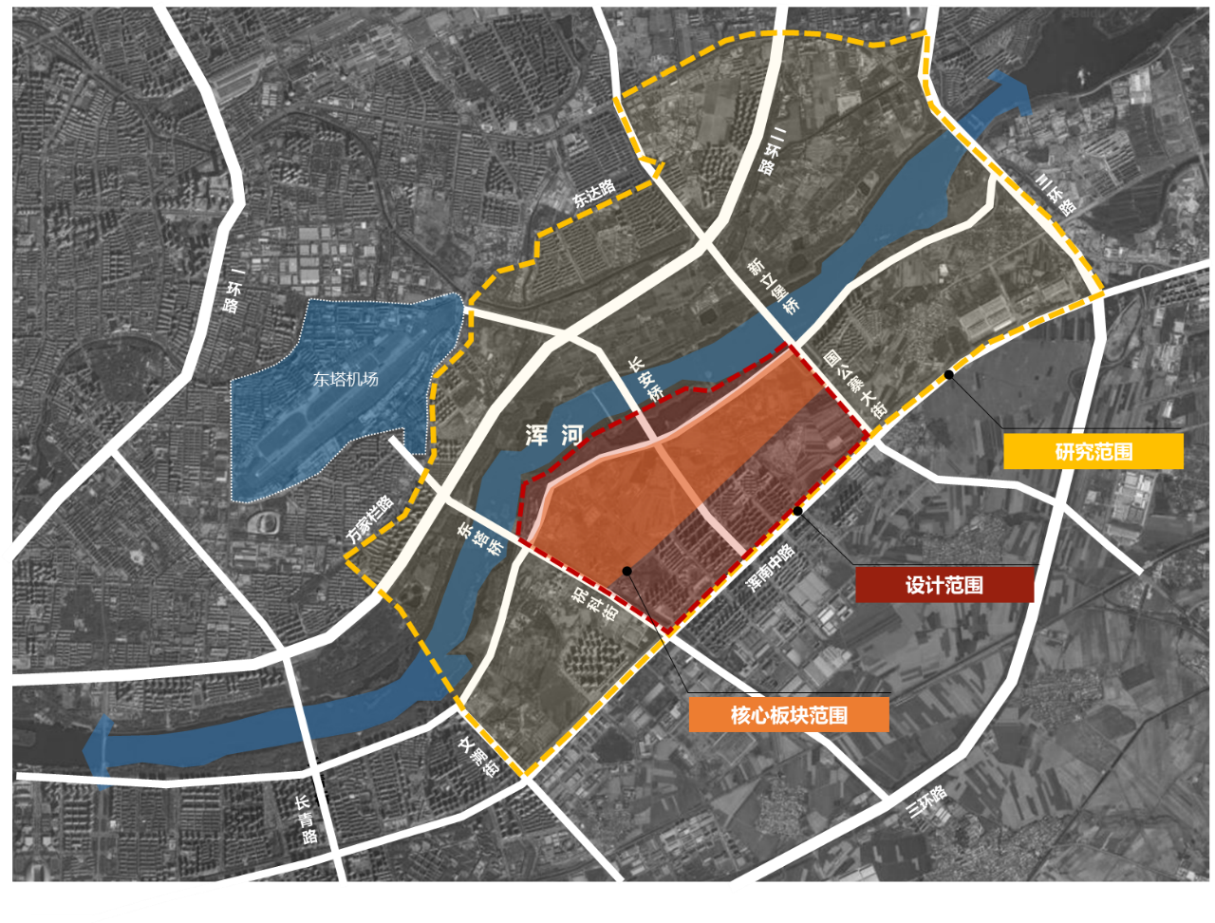
图2 工作范围示意图
Schematic diagram of working range

