附件2：
Appendix 2:

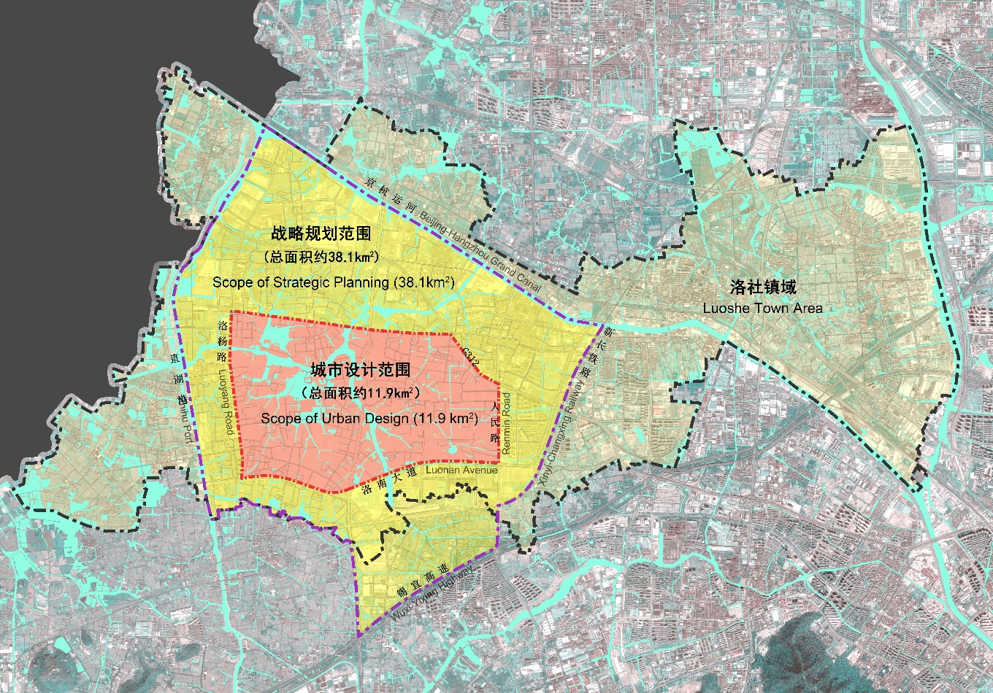
图2. 基地规划范围图
Figure 2. Diagram of the planning scope

