《赣南未来科技城战略规划与城市设计》
国际方案征集预公告
Pre-announcement on International Solicitation for
Strategic Planning and Urban Design of Gannan Future Science and Technology City
附图
Figure
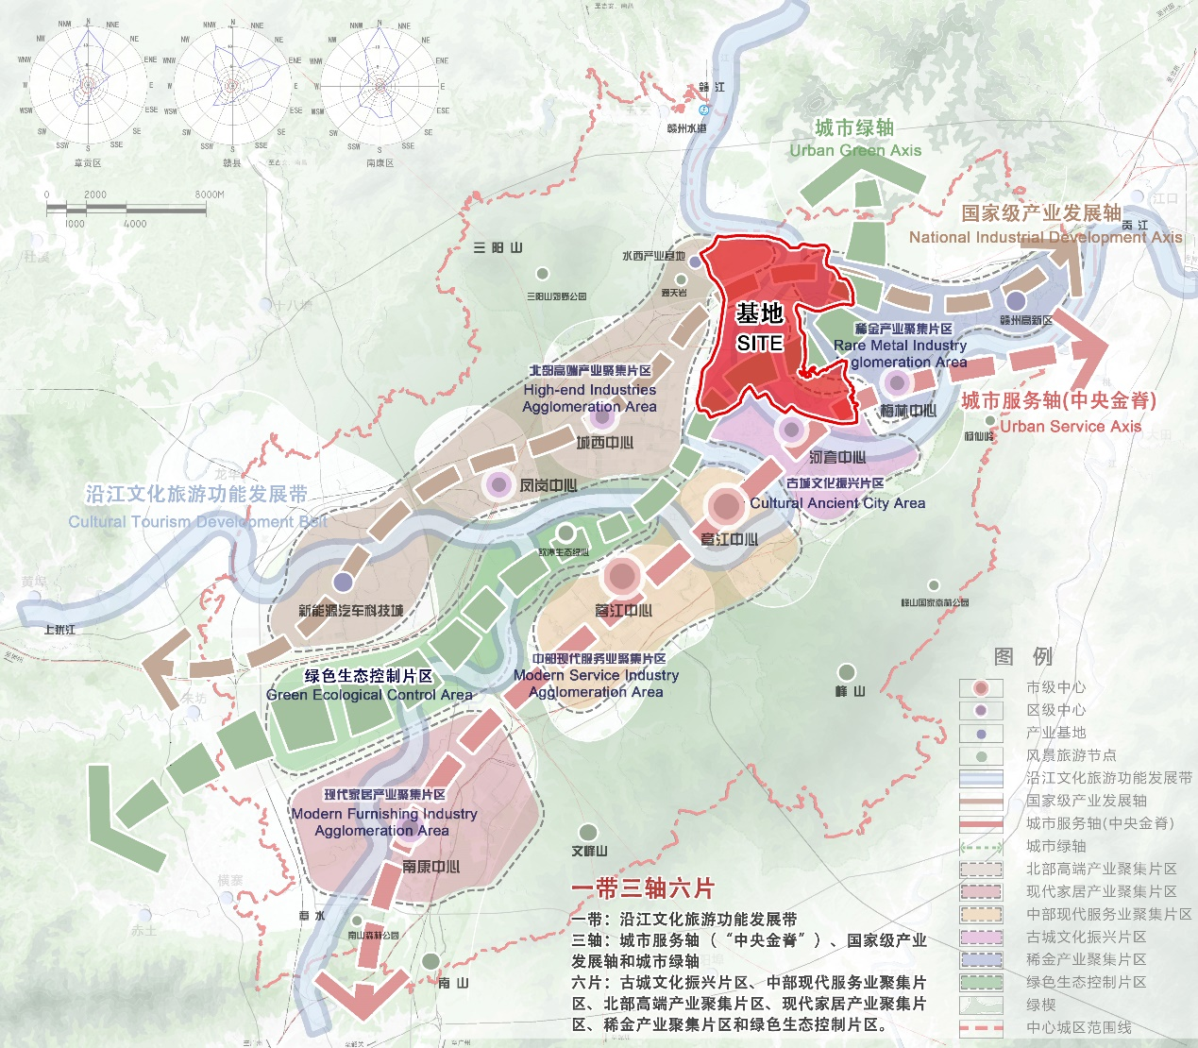
附图1 赣南未来科技城区位示意图
Figure 1. Location of Gannan Future Science and Technology City

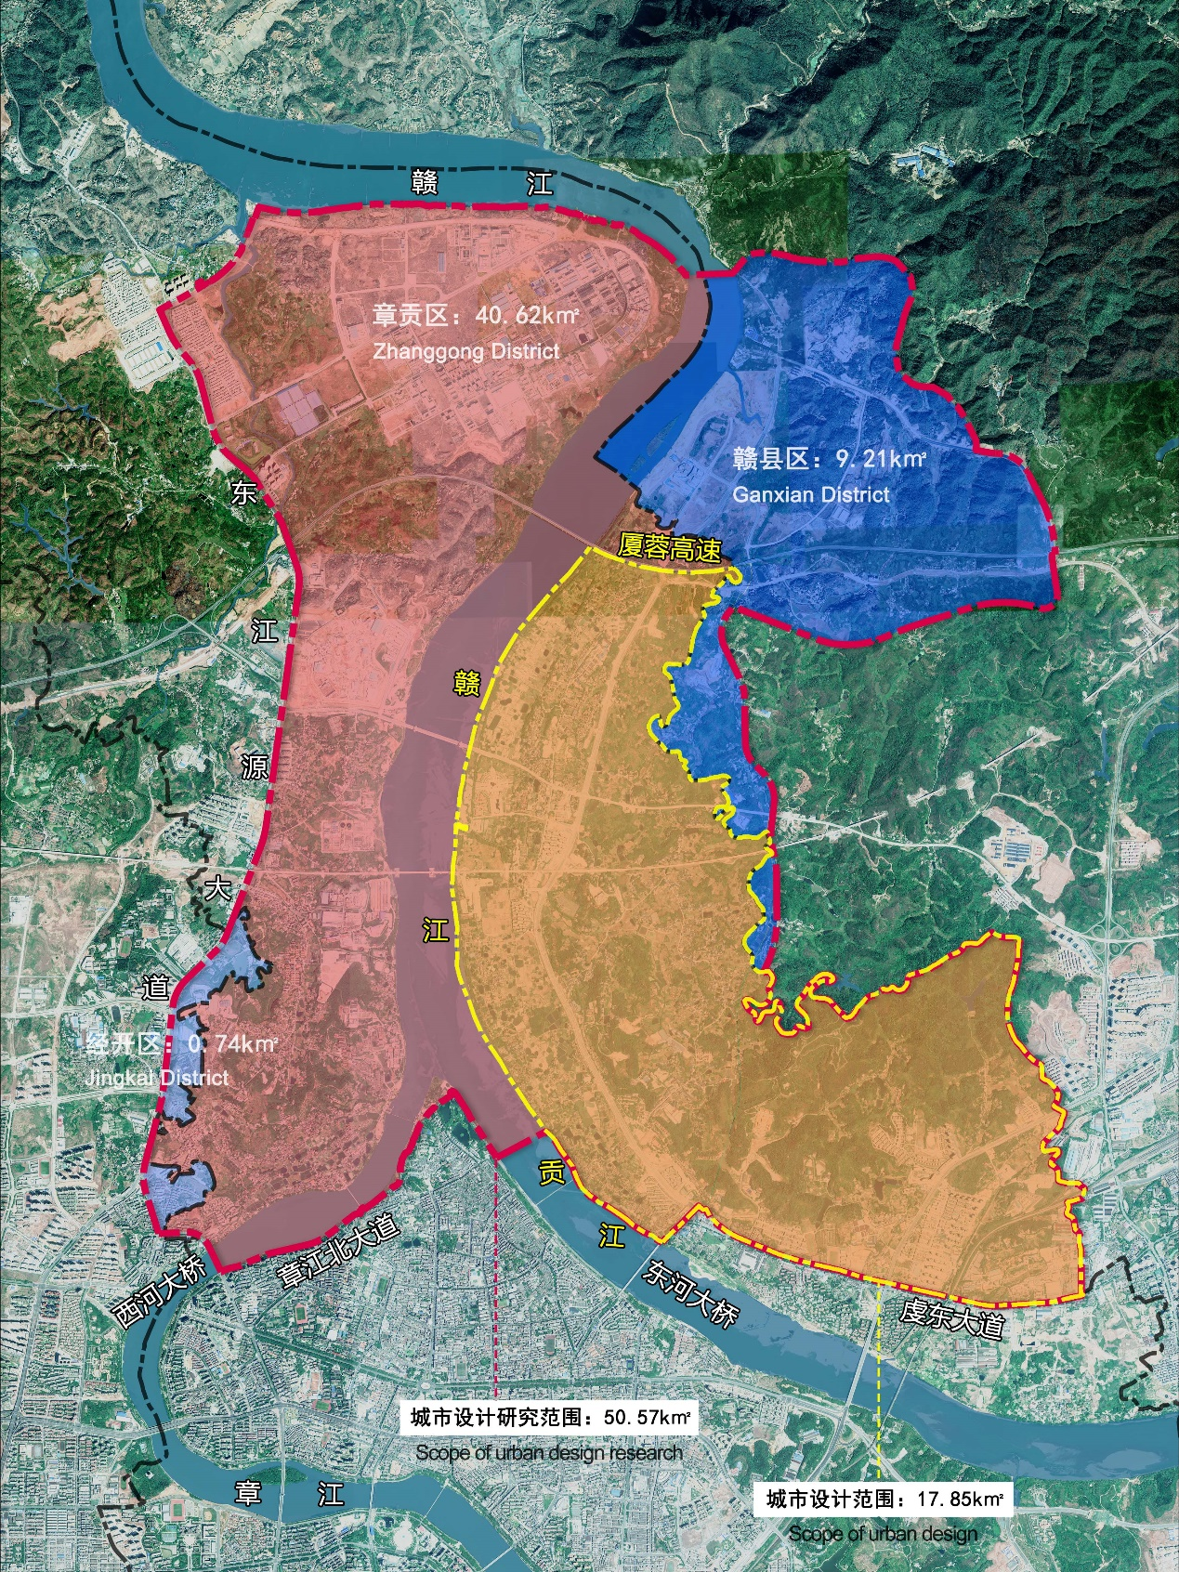
附图2 城市设计范围示意图
Figure 2. Scope of Urban Design

