石狮永宁滨海（新沙堤-西岑）片区城市设计方案
国际征集
International Competition of Urban Design for Shishi Yongning (Xinshadi-Xicen) Coastal Areas
（技术任务书）

项目背景
Project background
石狮永宁滨海（新沙堤-西岑）片区是石狮滨海休闲旅游带的重要组成部分，是石狮发展全域旅游的首善之区，是石狮历史文化特色的展示窗口，面向城市高质量发展和人民日益增长的美好生活需要，以塑造国际滨海旅游城市为目标，亟需重塑永宁滨海片区城市格局，整合城市资源，塑造石狮滨海文化旅游新名片。
Shishi Yongning (xinshati xicen) coastal area is an important part of Shishi Binhai leisure tourism belt. It is the best area for Shishi to develop all-for-one tourism. It is also a display window of Shishi's historical and cultural characteristics. Facing the high-quality development of the city and the people's growing needs for a better life, it is urgent to reshape the urban pattern of Yongning coastal area in order to shape an international coastal tourism city. Integrate urban resources and create a new name card of Shishi coastal cultural tourism.

项目区位
Project location
石狮位于福建省东南沿海、泉州湾南端；三面临海，西与晋江接壤，东临台湾海峡。有围头疏港高速与沈海高速相接，联通厦漳泉，交通便捷，是厦漳泉一体化的核心区域，项目位于石狮南部滨海地区，世界遗产项目“泉州·宋元中国的海上商贸中心”的缓冲区和景观控制区内。
Shishi is located in the southeast coast of Fujian Province and the south end of Quanzhou Bay; Surrounded by the sea on three sides, it borders on Jinjiang River in the West, and it is adjacent to the Taiwan Strait in the East. Weitou Shugang expressway is connected with Shenhai expressway, connecting Xiamen，Zhangzhou and Quanzhou. With convenient transportation, it is the core area of Xiamen,Zhangzhou , Quanzhou integration. The project is located in the coastal area in the south of Shishi ，it’s in the buffer zone and landscape control zone of the World Heritage Project "Quanzhou, Song and Yuan China's Maritime Trade Center"

设计范围
Design scope
规划总范围为13.8平方公里，方案分两个层面，总体城市设计及核心区城市设计，三个核心设计区：A区71.5公顷，B区60.6公顷，C区148.4公顷。详见附图。
The total planning area is 13.8 square kilometers. The plan is divided into two levels, the overall urban design and the urban design of the core areas. There are three core design areas: area A(71.5 hectares), area B(60.6 hectares) and area C(132.5 hectares). See the attached figure for details
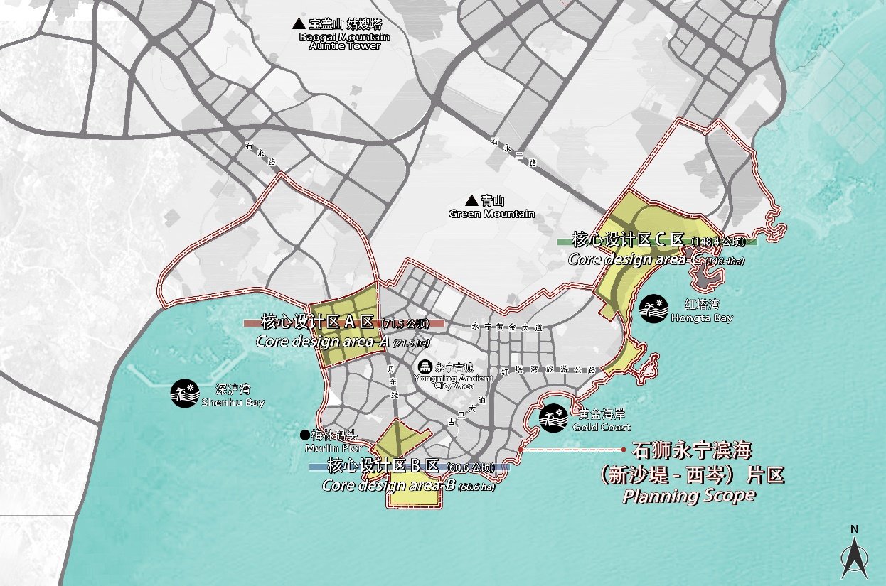
图 1设计范围示意图Figure 1 Schematic diagram of design scope

设计目标
Design goals
在厦漳泉一体化、建设泉州湾的背景下，主动谋划、积极融入城市群发展，统筹优质资源、挖掘独特文化;通过本次国际方案征集，为石狮滨海休闲旅游提供创新性发展思路，借鉴国内外先进城市案例和建设经验，充分利用永宁古城、黄金海岸等现有旅游资源，结合片区发展定位，将石狮永宁滨海（新沙堤-西岑）片区打造成为一流的滨海文化旅游休闲目的地，以文化传承、时代风尚、生态宜人的滨海旅游区打造新时代石狮发展的新动力。
本次国际征集方案将指导下一步控制性详细规划编制。
Under the background of the integration of the Integration of Xiamen, Zhangzhou and Quanzhou and the construction of Quanzhou bay area, actively plan and actively integrate into the development of urban agglomerations, coordinate high-quality resources, tap unique culture; Through this international competition, to provide innovative development ideas for Shishi coastal leisure tourism, learn from the cases and construction experience of advanced cities at home and abroad, make full use of the existing tourism resources such as Yongning ancient city and gold coast, and combine with the development orientation of the area, so as to build Shishi Yongning coastal area into a first-class coastal cultural tourism and leisure destination,and inherit cultural heritage and style of the times , the ecologically pleasant millennium coastal area creates a fresh impetus for the development of Shishi in the new era.
The international competition plan will guide the next step of regulatory detailed planning.

任务内容

项目总体规划
(1) Overall project planning

总体发展定位
1. Overall development positioning

充分研究厦漳泉一体化、环泉州湾建设的发展趋势和要求，以及石狮的结构定位、交通区位、文化特色等内容，以更高目标、更远谋划，提出滨海片区的发展定位和发展策略。
Fully study the development trend and requirements of the alliance of Xiamen, Zhangzhou and Quanzhou， Quanzhou bay, and the structural positioning, transportation location, cultural characteristics of Shishi, etc., with higher Target, further planning, proposing the development orientation and development strategy of coastal area..

总体发展策略
2. Overall development strategy
充分研究永宁古城、海岸沿线的文化和生态等资源，分析各板块资源的稀缺等级、吸引人群、市场潜力等，并统筹策划优质资源的组合形式、主题，大力提升石狮特色文化和旅游品牌的区域影响力，以及石狮的城市核心服务力。
Through the cultural and ecological resources of the Yongning Ancient City and the shoreline, analyze the scarce level, attracting people, market potential, etc., and coordinate the combination of high-quality resources, and vigorously enhance the Shishi characteristic culture and tourism brands. Regional influence, as well as the city core service of Shishi city.

总体功能布局
3. Overall functional layout
探索传统业态与新兴技术结合的路径，借鉴国际成功经验，基于古城、滨海旅游现状业态和历史记忆，考虑片区有机更新的不同时序下，为片区策划整体功能的空间布局。策划片区功能业态，合理布局各功能板块，高标准打造“国际滨海旅游目的地”。
Exploring the path of traditional age and emerging technologies, drawing on international success experience, based on the current status of the ancient city and coastal tourism, considering the difference in the ancient city to renew the overall function of the area. Plan the functional formats of the area, reasonably arrange the functional sections, and create an "international coastal tourism destination" with high standards

公共空间系统
4. Public space system
充分研究区域生态系统、现状水系，梳理片区现状公共空间，打造兼具生态价值和城市活力的公共空间体系；并形成连贯、特色的公共空间系统，串联和强化片区的景点，打造开放共享的公共空间系统。
Fully study the regional ecosystem, the current water system, combing the public space system of the area, create a public space system with ecological value and urban vitality; and form a coherent, characteristic public space system, series and strengthen the area attractions, and create an open share of public Space system.

综合交通系统
5. Integrated transportation system
结合地貌地形，充分研究片区道路交通条件和水运条件，从片区发展的需求考虑，结合区域高铁站点、港口码头、旅游板块的联动效益，提出片区水陆交通接驳的综合交通规划方案。
Combining with landform, fully study Road traffic conditions and water transport conditions, considering the demand for the development of the area, combined with the linkage benefits of the regional high-speed railway site, port terminals, tourism sectors, and proposes water and land transportation Comprehensive traffic planning scheme for connectivity.

公共设施布局
6.public facilities layout
基于片区文化旅游的服务需求，以及中心城区市民使用的需求，提出公共文化设施、商业服务设施等公共设施的空间布局，并对重点公共服务设施进行规模研究、空间形象详细设计。
Based on the service needs of the planning area cultural tourism, as well as the demand for public cultural facilities, commercial facilities such as public cultural facilities, commercial facilities, and scale research on key public service facilities, space image detailed design.

滨海岸线景观设计
7．Landscape design of coastal shoreline
综合研究滨海地区的自然资源、人文资源、景观资源及城市意向，提出滨海岸线景观设计理念，区分不同段落的不同特征，明确各段主题、空间功能、空间形态及重要节点景观意向等，界定滨海地区驳岸形态、植物配置、生态保护等内容。
Comprehensive study of natural resources, human resources, landscape resources and urban intentions in coastal areas. Put forward the coastal shoreline landscape design concept, distinguish different characteristics of different paragraphs ,and clarify the theme, spatial function, spatial form and landscape intentions of important nodes, and define the coastal revetment form, plant arrangement and ecological protection,etc.

空间风貌管控指引
8. Guidelines for the control of city features
梳理和评估有机更新的用地潜力和建设潜力，以及片区现有建筑的提升改造措施，并以此提出片区整体空间设计方案，重点关注天际线、建筑高度、开发强度、建筑风格，以及典型风貌界面、观景节点、片区风貌指引等建议，强调片区的个性特征与文化标识。分析片区内各区域与世界遗产点姑嫂塔以及永宁古城的空间关系，做好相关评估，建立合理区域空间模型。
Combing and assessing the land potential and construction potential of organic updates, and the improvement of the improvement of the area's existing buildings, and this is to present an city overall space design plan, focus on the skyline, building height , Development intensity, architectural style, and proposed suggestions such as typical appearance interface, viewing nodes, sequential style. Emphasis on the personality and cultural identity of the area. Analyze the spatial relationship between each region in the area with Gusao Tower(a World Heritage Site) and Yongning Ancient City, make relevant assessments, and establish a reasonable regional spatial model.

夜景亮化
9.Night scene lighting
基于片区文旅主题、设计理念和空间特色，明确需重点夜景亮化的特色街道、重点景区的主题，提出照明色彩和亮度、灯光布置、照明方式等内容，以及分时段的夜景活动策划等。
Based on the area theme, design concept and space characteristics, clearly need to focus on the characteristics of nightlighted streets, key scenic spots, proposing lighting color and brightness, lighting arrangement, lighting methods, etc., as well as night scene activities, etc.

地下空间开发
10．underground space development
考虑历史建筑、环境保护等需求，以及现状建设情况，结合地块功能提出建议方案，以及地下停车问题等，提出片区地下空间利用系统。
Consider the needs of historical buildings, environment protection, as well as the current situation construction, combined with plot function, and underground parking issues, the underground space utilization system is proposed.

运营模式
11．Operation mode
充分思考虑滨海旅游模式与发展特点，为业主方提供切实可行的运营模式，并提出建设时序。
Fully consider the coastal tourism mode and development characteristics, provide a feasible operation mode for the goverment, and put forward the construction sequence.

核心区详细城市设计(含重点建筑概念设计)
（2) Detailed urban design of the core area
核心区详细城市设计包括空间形态、景观营造、功能业态布局、风貌塑造、地下空间、技术经济指标、投资估算等内容，需对三大核心区的重点建筑、重要公共空间节点等进行建筑方案（（含主要建筑平面、立面及剖面））及景观节点设计。

The detailed urban design of the core area includes space form, landscape construction, functional layout, style shaping, underground space, technical economic indicators and investment estimation， etc. It is necessary to carry out architectural schemes (including main building planes, elevations and sections) and landscape node design for key buildings and important public space nodes in the three core areas.

七、成果要求 Results requirements

成果内容
1.Outcome
- 文本及说明
(1) Text and instructions
详细阐述方案的必要文本及说明,可按图文混排方式，成果深度满足国家规范要求内容。
提出本次城市设计思路，具体详实的阐述目标愿景、文旅品牌打造策划、综合交通系统、概念用地布局、城市设计方案、历史文物保护与利用方案、业态开发策划、重点片区详细设计、公共空间设计、城市景观设计、综合交通设计、建设强度引导、生态海绵设计、技术经济指标等。
The necessary text and description of the scheme will be described in detail,The depth of the results meets the requirements of the national regulations
Propose this urban design idea, detailed explanation of the target vision, Wen travel brand to create planning, integrated transportation system, conceptual landline, urban design plan, historical cultural relics protection and utilization plan, business development planning, focus area detailed design, public space Design, urban landscape design, integrated transportation design, construction strength guidance, etc.
（2）图纸及文件内容
(2) Drawings and document content
图纸不少于以下内容：现状分析图纸（若干）、概念性策划与空间开发管控规划图、表达设计概念和方案构思的相关图纸、城市设计总平面图、空间结构与功能板块示意图、用地布局规划图、综合交通规划图及相关分析图、城市设计范围主要道路断面图、公共开放空间及绿地系统规划图、慢行绿道系统图、夜景规划图、三维形态分析图、地下空间规划图、滨海驳岸设计图、总体鸟瞰图（若干含夜景）、重点片区与重要节点设计方案及效果图（若干），设计方可提供其他展示设计的分析图。
Drawings are not less than the following: Status analysis drawings (several), conceptual planning and space development management planning map, expression design concept and program concept related drawings, city design total plan, spatial structure and function plate diagram, landline planning map , Integrated traffic planning map and related analysis map, main road section map, public open space and green space system planning map, slow road system diagram, three-dimensional morphological analysis map, underground space planning map, coastal revetment design drawing, overall aerial views (several incude night view), key sections and important node design schedules and rendering (several), the design can provide an analysis of other display designs.

成果形式
2．outcome form
文册：研究报告文册按A3规格（297×420），正本1份，副本20份，无篇幅限制要求，采用双面软胶装的规格进行打印装订。
Word: Research Report Cultus According to A3 Specifications (297 × 420), 1 original and 20 copies, non-unparalleled restriction requirements, using double-sided soft rubber specifications for printing.
简本：A3规格（297×420），正本1份，副本20份，页面不超过30页（单面打印），展示方案核心内容及关键图纸为主。
Simply: A3 specification (297 × 420), 1 original and 20 copies, page no more than 30 pages (single-sided print), display the core content and keylights of the display.
展板：规格（840×1180，横版）1套，图版装裱，数量6张，用阿拉伯数字在展板的右下角排序编号。
Exhibition Board: Specifications (840 × 1180, horizontal version) 1 set, diagram version installed, 6 photos, sorted by the Arabic number in the lower right corner of the showboard.
多媒体演示系统：方案介绍MP4、AVI 或WMV 格式，时间控制在8-10分钟（包含动画两分钟），清晰度要求4K及以上，要求中文普通话配音。
Multimedia Demo System: Plan introduces MP4, AVI or WMV format, time control at 8-10 minutes (including two minutes of animation), definition requirements 4K and above, require Chinese Mandarin dubbing.
现场汇报演示文件：PPT格式，汇报时间控制在35分钟内（含翻译时间）。
On-site reporting document: PPT format, report time control within 45 minutes (including translation time).
电子文件：以u盘形式提交，一式2份，含研究报告（PPT、doc 文件或可编辑的PDF 文件）、CAD 图纸（DWG 文件）、三维数字化模型文件（Sketch up 及3Dmax文件格式，用于置入城市仿真平台）、评审展示用图（A0，300DPI 的JGP 或PDF文件）、多媒体演示系统（MP4、AVI 或WMV 格式）、现场汇报演示文件（PPT或PDF 文件）等。
Electronic file: Submitted in U disk in duplicate, including research report (PPT, DOC file or editable PDF file), CAD drawing (DWG file), three-dimensional digital model file (Sketch Up and 3Dmax file format, for setting Entering the city simulation platform), review show (A0, 300DPI JGP or PDF file), multimedia demo system (MP4, AVI or WMV format), on-site reporting file (PPT or PDF file), etc.

