《霞客湾科学城战略规划与概念性城市设计》
国际方案征集公告
附图
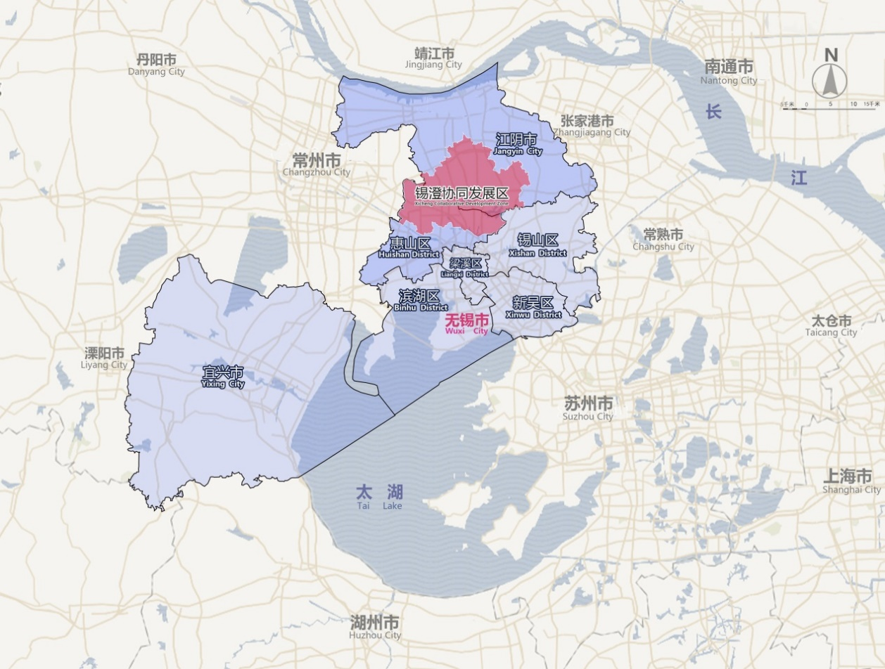
图1：锡澄协同发展区区位示意图
Figure 1. Location Diagram of Xicheng Cooperative Development Zone

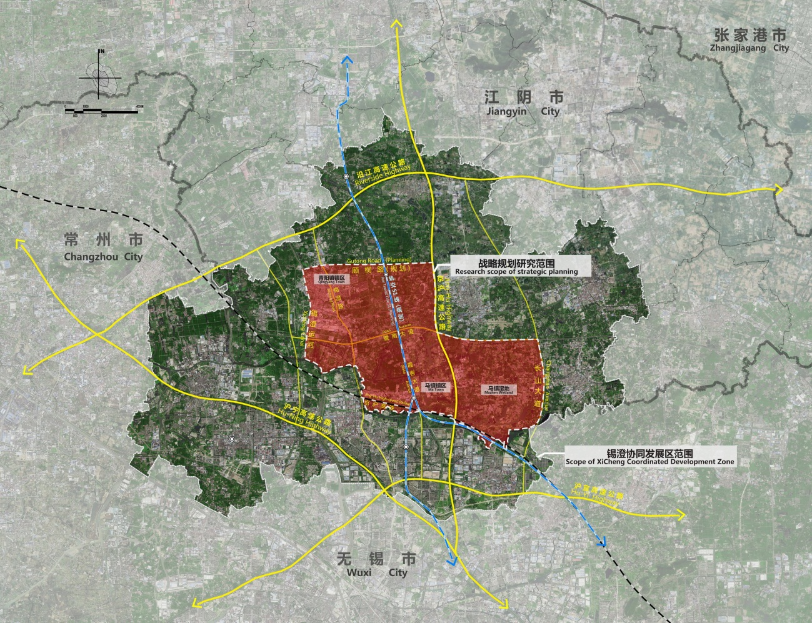
图2：战略规划研究范围示意图
Figure 2. Diagram of Strategic Planning Research Scope

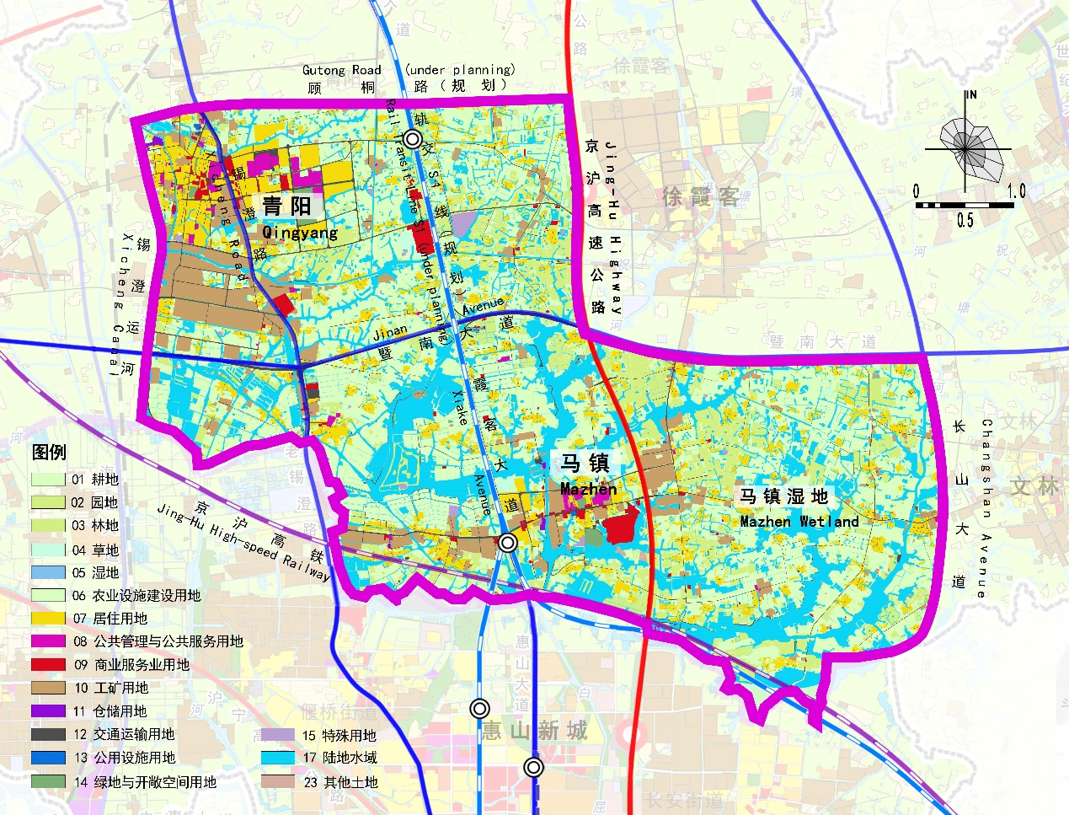
图3：战略规划研究范围现状图
Figure 3. Current Status of Strategic Planning Research Scope

