西部（重庆）科学城金融街片区
概念规划及一期方案设计
国际征集公告
附图
Public Solicitation for International Consultancy on Conceptual Planning and Phase I Scheme Design of the Financial Street Area in Western (Chongqing) Science City
附件1
Appendix :
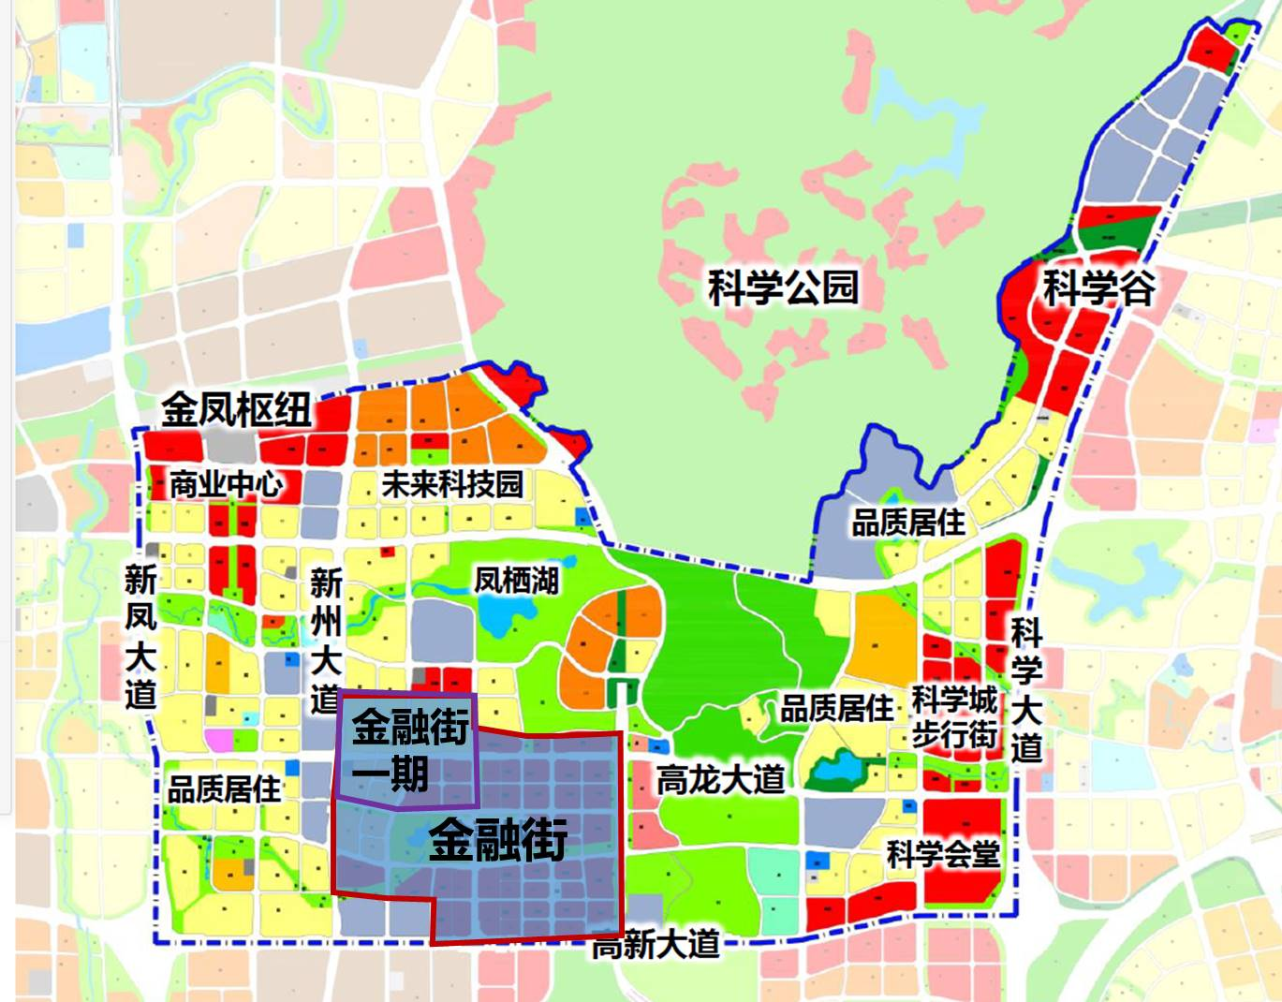
图1 金融街区位图 Location map of the Financial Street
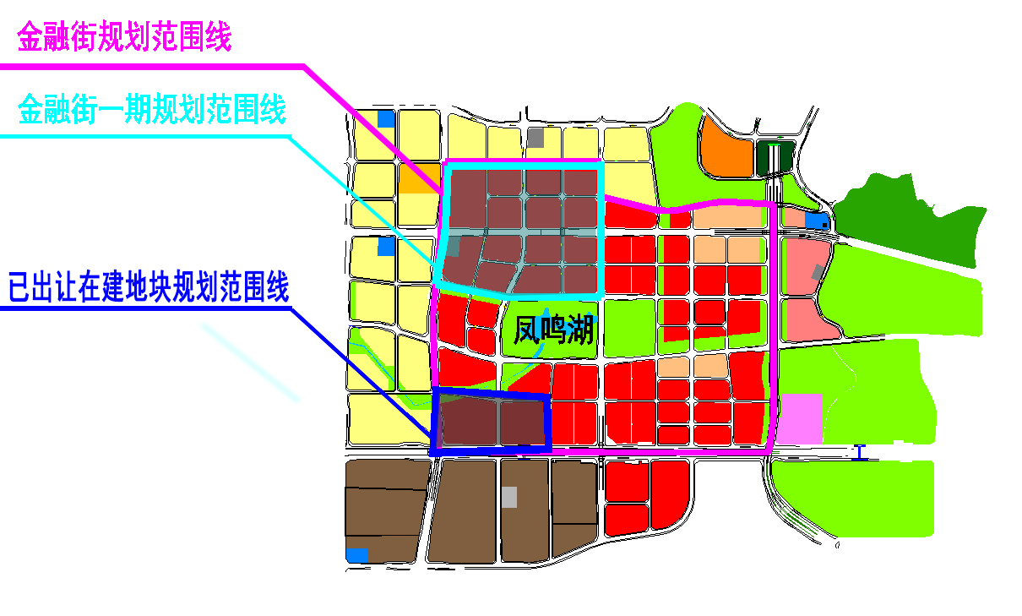
图2 金融街规划范围 Planning range of the Financial Street

