《“东海瀛洲·风情渔港”——衢山岛双龙湾地区概念规划》
国际方案征集公告
附图
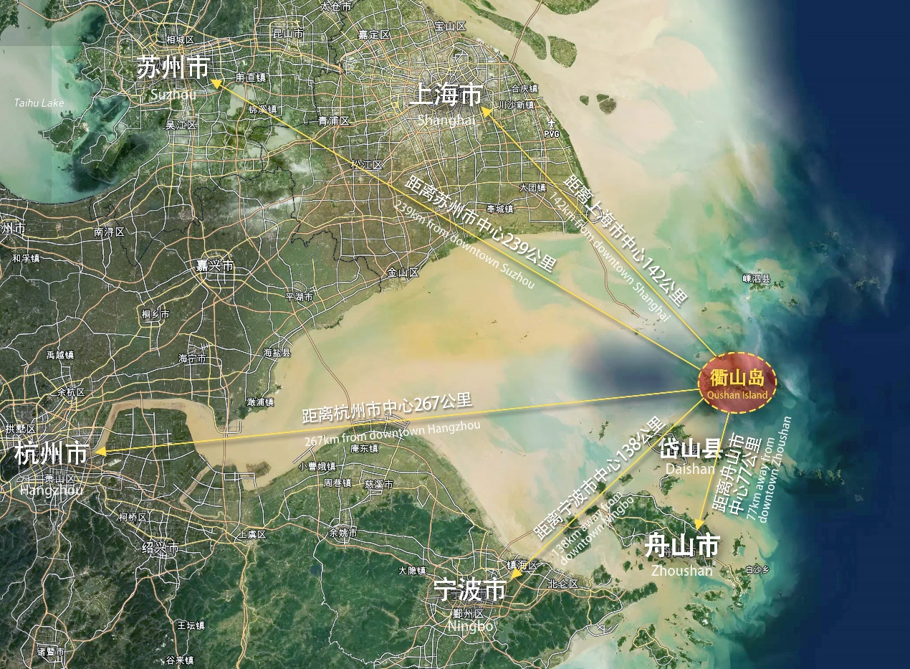
图1. 衢山岛区位图
Figure 1. Location of Qushan Island
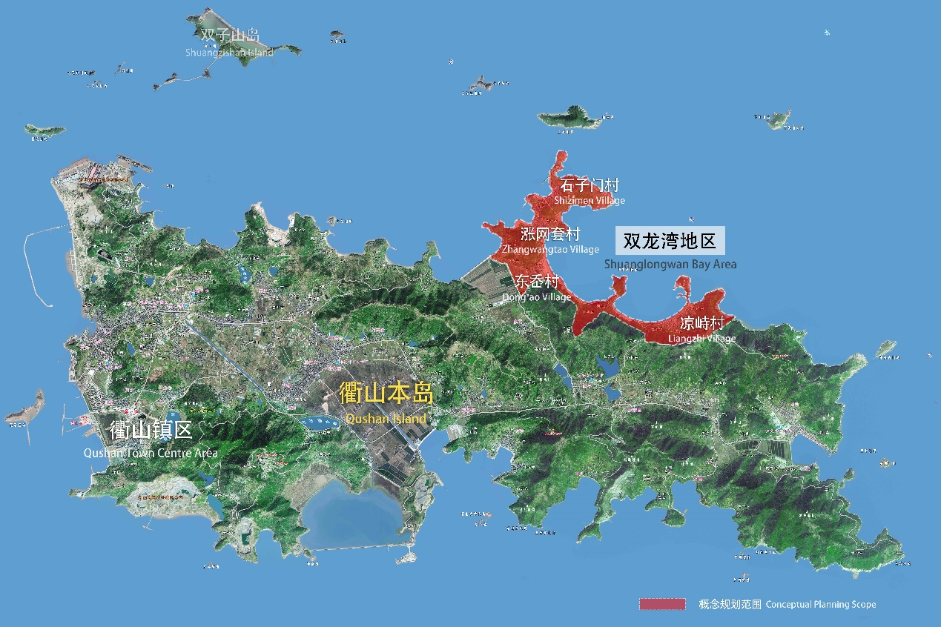
图2 规划研究范围与概念规划范围示意图
Figure 2. Diagram of Planning Research Scope and Conceptual Planning Scope

