重庆市广阳岛智创生态城
城市设计征询公告附图
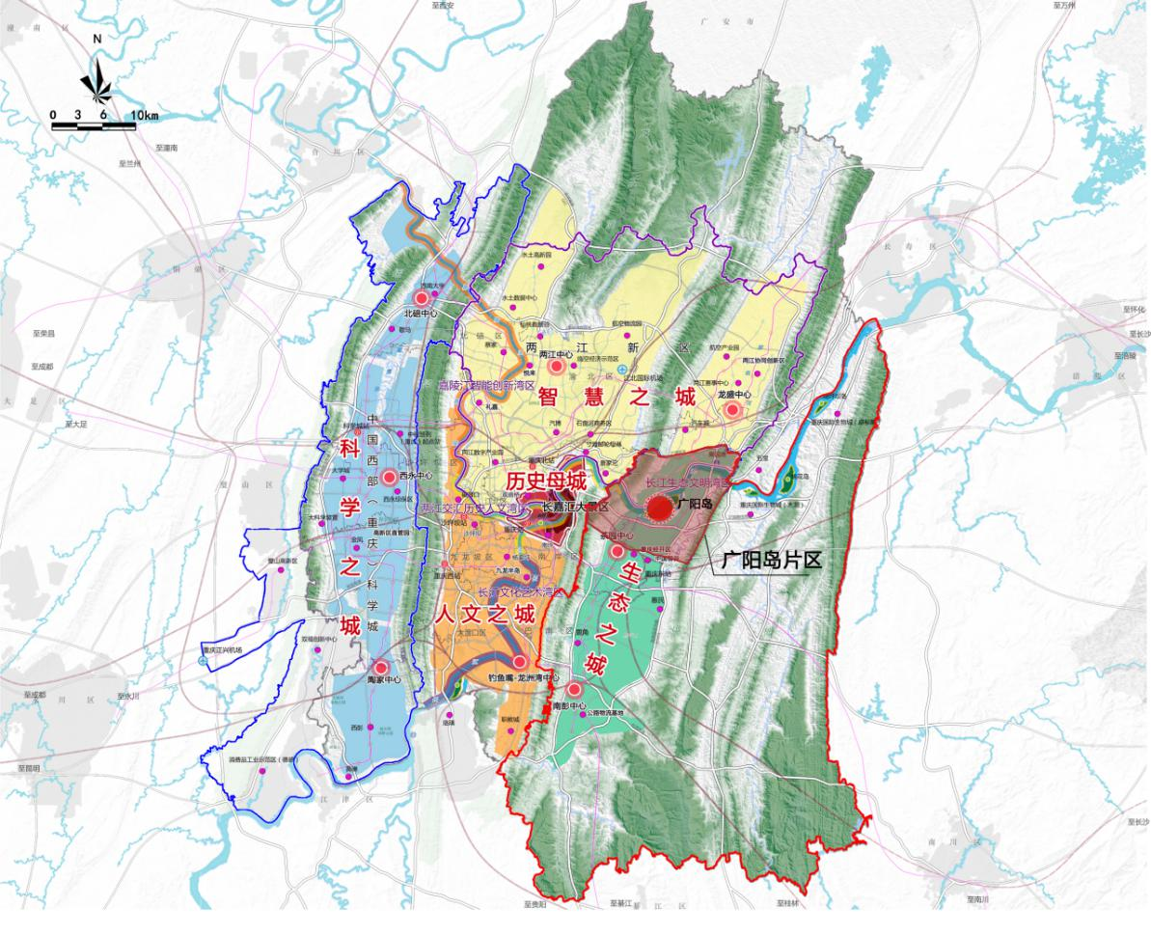
广阳岛片区区位图
Location of Guangyang Island Area
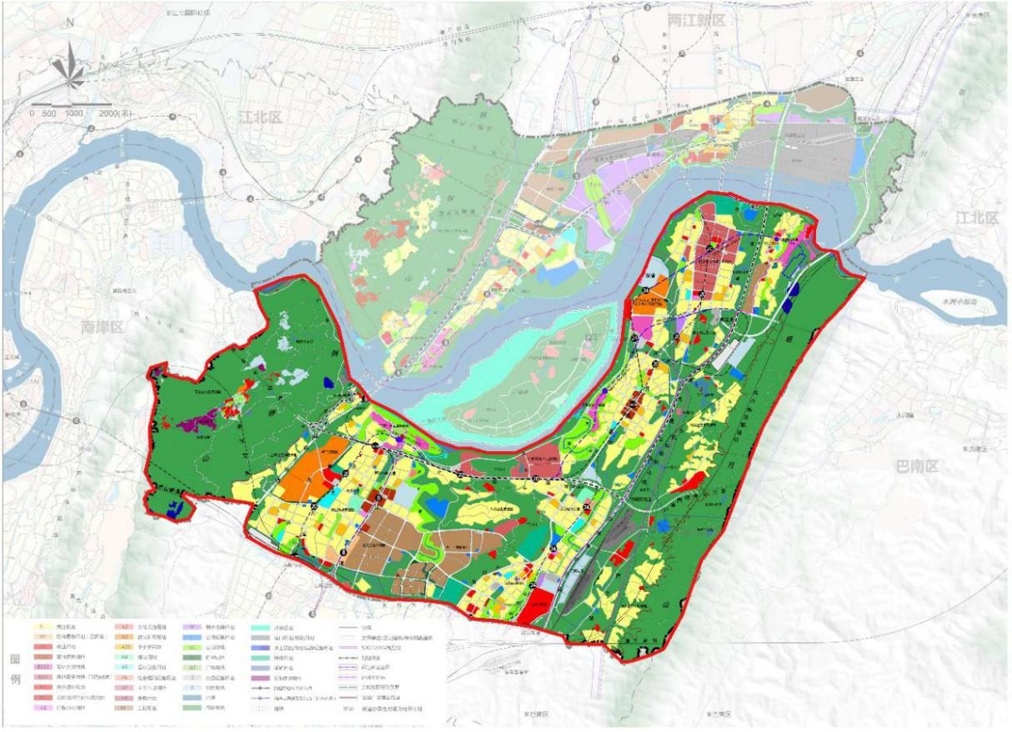
广阳岛智创生态城总体城市设计规划范围
The Overall Urban Design Planning Scope of Guangyang Island Smart Innovation Eco-city

